DSA4213 Assignment: Language Models, Embeddings and Representations on IMDB Reviews
Kho Zhe Ming A0271660H Code: GitHub Link

Experimental Focus
We train four next-token language models (LMs) on the same corpus of movie reviews (Part I), vary the input embeddings of one of the models in Part I (Part II) and reuse all trained LMs as frozen feature extractors for sentiment classification (Part III). The question that links the three parts is: does better next-token prediction lead to better review representations for sentiment classification? At the same time, we want to find out how model families differ on our corpus and whether fixed embeddings help with better classification. From the results of the experiment, we conclude that the ranking of models by test perplexity does not predict their ranking by downstream accuracy. The choice of input embedding and pooling has a larger effect than the LM loss.

Data, preprocessing and evaluation setup
2.1 Dataset
We use IMDB Movie Reviews (Maas et al., 2011) with 50,000 English reviews labelled positive/negative. We removed 418 duplicate reviews (49,582 remain) so that no text can appear in both training and test data. We then shuffled once (seed 42) and took a manageable subset: 20,000 training, 2,500 validation and 2,500 test reviews. The remaining 24,582 reviews are unused.
2.2 Data Preprocessing
We lower-case the text, strip HTML tags (<br />) and tokenise in the GloVe style (don't → do n't, it's → it 's, punctuation as separate tokens). Each review keeps only its first 128 tokens: the median review has 200 tokens and the mean has 267, so 85% of reviews are truncated. This is a decision made with computation cost in mind and its cost is analysed in Section 5. The vocabulary contains the 9,996 most frequent training words plus <pad>, <unk>, <bos> and <eos>. The out-of-vocabulary (OOV) rate is 4.2% on training text and 4.5% on test text. Each review becomes <bos> w₁ w₂ … w_{n} <eos>. Inputs and targets are shifted by one position and right-padded.
2.3 Evaluation Setup
Every model predicts each token only from the preceding tokens of the same review, and all four models are scored on the identical set of 307,996 test targets (words and <eos>; padding is excluded). We report token-weighted cross-entropy (CE: the mean of −ln p over the true next tokens, in nats) and perplexity (PPL = exp CE). Since all models share the vocabulary and targets, PPL is comparable across our models, but not with published numbers that use other vocabularies. The training budget for all neural LMs is set as: Adam (learning rate 10⁻³, gradient-norm clip 1.0), batch size 64, at most 10 epochs, early stopping on validation loss (patience 2) with best weights restored, seed 42.
All experiments ran on a laptop CPU with no GPU: Intel Core 7, 16 GB RAM, Windows 11, Python 3.12, TensorFlow 2.18. Times are wall-clock (time.perf_counter). Training time covers the full fit, including the validation pass each epoch. The common inference workload is scoring the entire test split (307,996 targets) at batch size 64 after one warm-up batch, reported as tokens/s. Generation latency is the mean time per generated token over 5 prompts × 30 tokens; for the neural models it recomputes the full prefix at every step, which disadvantages the recurrent models.

Part I: Language-model comparison
Table 1. Models. *Non-embedding parameters = parameters excluding the input embedding and output softmax layers. All neural models use randomly initialised, trainable embeddings.
Model | Architecture (dropout 0.1 for neural models) | Context | Total params | Non-embedding parameters*
Trigram | Interpolated trigram/bigram/unigram (add-1); λ = (0.20, 0.45, 0.35) grid-searched on validation | 2 tokens | 1.80M n-gram entries | –
RNN | Emb(100) → SimpleRNN(256) → Dense(10k) | ≤128 tokens | 3.66M | 91k
LSTM | Emb(100) → LSTM(256) → Dense(10k) | ≤128 tokens | 3.94M | 366k
Transformer | Emb(100) + learned positions → 2 pre-LN blocks (4 heads, FFN 256, causal mask) → LN → Dense(10k) | ≤128 tokens | 2.21M | 198k

The embedding size of 100 matches GloVe-100d so that the Part I LSTM can serve directly as the random-embedding setting in Part II. We kept the models small so that each trained in about 1 hour on CPU, and sized the Transformer's non-embedding parameters in between the RNN's (91k) and the LSTM's (366k). Note that over 90% of each neural model's parameters sit in the embedding and output layers, so total parameter count says little about the sequence-modelling capacity.
Table 2. Prediction quality and cost. Trigram (no iterative training, single counting pass plus λ grid search).
Model | Test CE | Test PPL | Train time | Seconds per epoch | Inference tokens per second | Generation time per token (ms/token)
Trigram | 4.894 | 133.4 | 9.6 s | – | 463,016 | 0.5
RNN | 4.684 | 108.2 | 47.4 min | 284 | 11,933 | 59.8
LSTM | 4.805 | 122.1 | 58.5 min | 351 | 8,985 | 53.3
Transformer | 4.512 | 91.1 | 34.3 min | 206 | 16,108 | 38.5

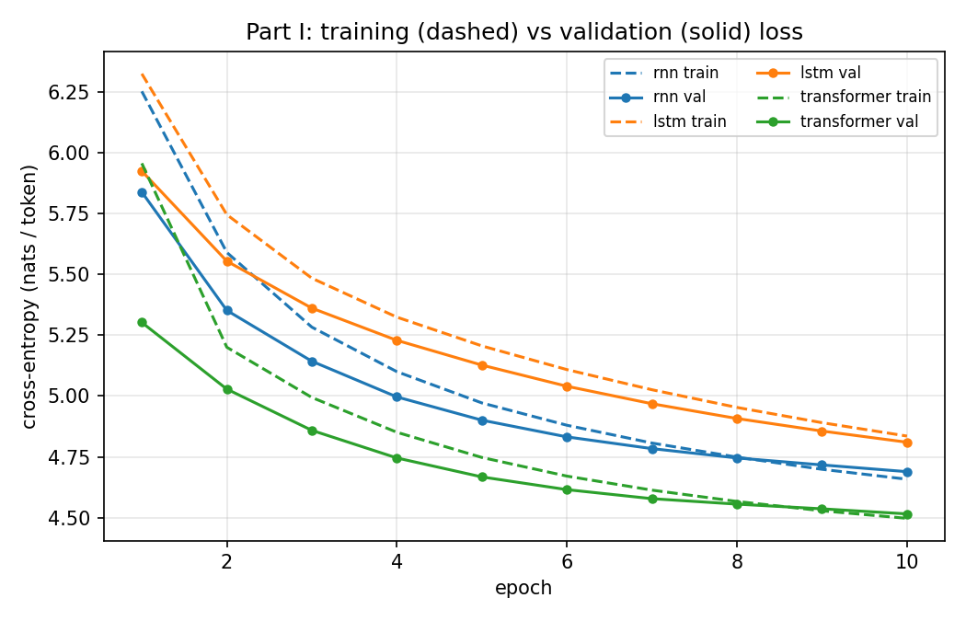 | 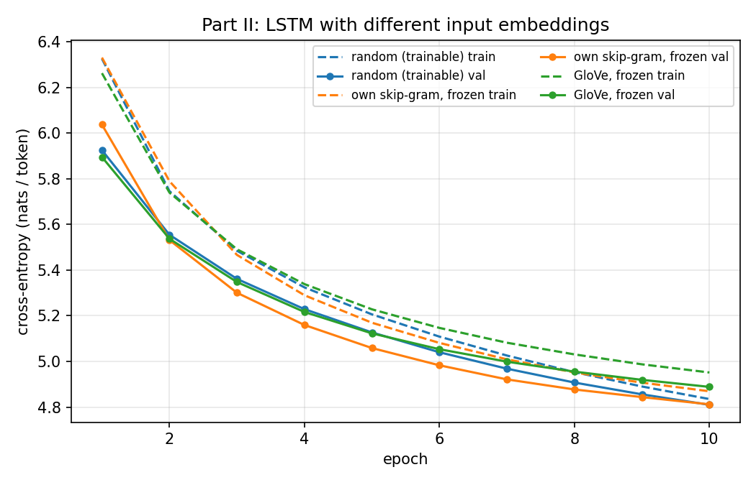
Figure 1. Training (dashed) and validation (solid) loss. Left: Part I neural LMs. Right: Part II LSTM embedding variants. Training loss is measured with dropout active and averaged over each epoch.

3.1 Observations
- Prediction quality (Table 2): Transformer (91.1) < RNN (108.2) < LSTM (122.1) < trigram (133.4). All neural models beat the trigram in terms of test PPL.
- Training and inference cost (Table 2): The trigram trains in 10 s and scores many more tokens per second than the neural models. Among the neural models, the Transformer is both the most accurate and the cheapest on CPU: 206 s per epoch versus 284 s (RNN) and 351 s (LSTM), and 16k tokens/s at inference.
- Learning behaviour: None of the neural network runs triggered early stopping as validation loss was still falling at epoch 10 for all three models, so the best epoch = 10 throughout. These results therefore reflect a fixed 10-epoch budget rather than convergence. Given more compute power, more epochs can be used to test if the validation loss goes to convergence. There is no overfitting. Validation loss sits below training loss early on, because training loss includes dropout and is averaged while the weights are still improving. By epoch 10, RNN and Transformer training loss has fallen just below validation loss (gaps of 0.03 and 0.02 nats), the first sign of fitting the training set. The LSTM's validation loss was still dropping fastest in the last epoch (−0.046 nats, versus −0.028 for the RNN and −0.021 for the Transformer).
- Generated text (Table 3, all outputs in Appendix B): Using a temperature of 0.8, top-k 40, 30 tokens and same seed per prompt, the trigram produces 2–3 word fragments that break down quickly, including punctuation runs ("one of the . . . .") and ungrammatical joins ("i am . the to - ,"). The RNN and LSTM produce clause-length grammatical spans ("i have to admit that this film is a"), but their sentiment drifts and the LSTM sometimes repeats punctuation (". . . . . ."). The Transformer is the most fluent and stays in the review register ("the acting was horrible . the story is the biggest disappointment"). No model stays consistent beyond about one sentence as contradictory sentiments within one continuation are common to all four (e.g. Transformer: "very good … the acting was horrible"). These observations rest on 5 prompts with one sample each.
Table 3. Selected prompt continuations (tokenised output). Full output in Appendix B.
Prompt | Model | Continuation (first ~20 tokens)
this movie was | Trigram | a movie . . " the film . one of the . . . . i was able to me . i 've ever seen …
 | RNN | actually directed by the bad guys who saw it in a year , and i am sure we watch it …
 | LSTM | also a great film and a lot of humor , i watched this film . i was hoping to watch it …
 | Transformer | very good . the problem i saw a bit of a very good movie . the acting was horrible …
i would not recommend | Trigram | that it was the only one even on the film . i am . the to - , be prepared …
 | Transformer | this film to the same time . i have seen the movie , and i never seen this movie , i just sat through it …

3.2 Explanations and trade-offs
The Transformer's lead is not explained by size: it has the fewest total parameters, and its non-embedding parameters are about half the LSTM's (Table 1). Likewise, the LSTM has 4× the RNN's non-embedding parameters but performs worse. Parameter count therefore does not explain prediction quality. A more plausible explanation is the Transformer's direct attention to every earlier token, whereas recurrent models must compress the whole prefix into one hidden state. Its lower cost has two likely causes: it processes all positions in parallel, and its output layer projects 100-dimensional rather than 256-dimensional states onto the 10,000-word vocabulary. That output layer accounts for most of the compute per token in every neural model, which is also why the LSTM costs only 1.24× the RNN per epoch despite its 4× larger non-embedding parameters.
The LSTM trailing the RNN is unusual. Its gates and 4× larger non-embedding parameter count typically need more updates, its validation loss was still falling fastest when training stopped, and 128-token truncation removes the long-range dependencies where gating helps most. We therefore attribute the gap to the training budget rather than the architecture, but cannot confirm this without longer runs. Equal epochs also do not mean equal compute: the Transformer trained for 34.3 minutes in total and the LSTM for 58.5 minutes, so at an equal time budget the LSTM would trail by even more.
All neural models beat the trigram. One likely reason is that embeddings let similar words share information, so the neural models generalise to contexts never seen in training, while the trigram relies on exact counts. Those counts are sparse (1.8M n-gram entries from 2.5M training tokens), and tuning gives the bigram term the most weight (λ₂ = 0.45), so the trigram context is often too sparse to rely on. Its 2-token window is consistent with its grammar breaking down within a few tokens.
The trigram is the choice when compute is minimal: it reaches a PPL of 133 in 10 s of CPU time, but cannot generalise. At this context length, budget and hardware, the Transformer is the best overall choice, with both the lowest perplexity and the lowest neural training cost. However, its attention cost grows with the square of context length. Recurrent models showed no advantage at this budget. The LSTM might benefit from a larger budget, which our compute budget did not allow us to test.

Part II: Embedding variants (LSTM)
We keep the Part I LSTM and change only its input-embedding table. The embedding dimension (100), the rest of the architecture, the data, the seed and the training procedure are all identical. The random, trainable setting is the Part I LSTM itself. We train two new LMs whose embedding tables are frozen.
- Own embeddings: Skip-gram (gensim; window 5, 5 negative samples, 5 epochs), trained on the same 20k truncated training reviews, with out-of-vocabulary words mapped to <unk> and <bos>/<eos> included. It therefore covers 100% of the vocabulary, special tokens included.
- Public embeddings: GloVe 6B-100d, trained on 6B tokens of Wikipedia and Gigaword. It covers 99.73% of our word types (27 missing) and 99.96% of word tokens. The missing words are mostly tokenisation artefacts of quoted words ('the, 'a), Windows-1252 punctuation and rare names ('hara, 'toole).
- Missing rows: GloVe has no vectors for <unk>, <bos> and <eos> either. These rows and the missing words are drawn from N(0, σ), where σ is the standard deviation of the found vectors, and <pad> is set to zero.
- Freezing: in both frozen settings the entire table, including these random rows, is frozen (trainable=False). We checked that it is unchanged after training.

Table 4. Embedding ablation (same LSTM, same 10-epoch budget).
Embedding setting | Trainable / frozen params | Test PPL | Validation loss at epochs 1 / 5 / 10 | s / epoch | Validation-loss increases
Random, trainable | 3.94M / 0 | 122.1 | 5.925 / 5.127 / 4.810 | 351 | 0
Own Skip-gram, frozen | 2.94M / 1.00M | 122.6 | 6.037 / 5.059 / 4.812 | 329 | 0
GloVe 6B-100d, frozen | 2.94M / 1.00M | 132.2 | 5.895 / 5.123 / 4.889 | 327 | 0

Table 5. Nearest neighbours (cosine similarity) in each input-embedding table.
Word | Random (after LM training) | Own Skip-gram | GloVe 6B
good | great, decent, bad, horrible, lousy | decent, great, bad, fine, cool | better, sure, really, kind, very
funny | boring, predictable, unrealistic, laughable | hilarious, amusing, scary, witty | hilarious, amusing, weird, scary
boring | predictable, incoherent, entertaining, funny | dull, pointless, tedious, predictable | tedious, dull, bored, funny
plot | story, drama, premise, storyline | storyline, story, convoluted, dialogue | plots, plotting, conspiracy, story

4.1 Observations
- Test prediction quality: The own Skip-gram setting matches the random, trainable setting (PPL 122.6 vs 122.1). That 0.4% gap is small enough to be seed noise, although with a single seed we cannot measure that noise. GloVe is clearly worse, at 132.2 (+8%)
- Convergence: The three settings take different paths to their final losses (Table 4, Figure 1 right). For the Skip-gram, it starts worst at epoch 1, has the lowest validation loss from epoch 2 to 9, and is caught by the random setting only at epoch 10. For GloVe, it starts best at epoch 1 and tracks the random setting until epoch 5, then falls steadily behind, finishing 0.08 nats worse. None of the three converged as all were still improving at the 10-epoch cap
- Training stability: All three runs trained smoothly: validation loss never rose from one epoch to the next, and neither curve shows spikes. With one seed per setting we cannot compare run-to-run variance, so we can only say that none of the settings is unstable.
- Generated text (Appendix B): There is no consistent difference between the settings. All three produce locally grammatical clauses and all three contradict themselves on sentiment.
- Cost: Training our own Skip-gram embeddings took 38.4 s, about 1% of one LSTM training run, and is reported separately from LM training. Freezing the table removes 1.0M trainable parameters and makes each LSTM epoch about 6.5% faster (329 s vs 351 s). As a result, the whole own-embedding pipeline (38 s + 3,292 s) was slightly cheaper than training the random setting (3,507 s). GloVe cost us only 4.8 s to load, but the cost of pre-training it on 6B tokens was paid elsewhere.

4.2 Interpretation
Freezing an embedding table that was well matched to the domain cost nothing in final quality. The Skip-gram LSTM reached the same perplexity as the trainable LSTM, so at this budget the remaining 2.9M trainable parameters could fully compensate for an input table they could not change. The trainable table must learn useful word vectors from the LM loss, whereas Skip-gram supplies them from the start. A plausible reading of Skip-gram's lead in epochs 2–9 is that pre-trained distributional information speeds up early optimisation, and that the trainable table catches up once it has seen enough updates (hypothesis). Trainability therefore mattered little for final quality and somewhat for speed of learning.
GloVe was trained on about 2,400× more text than our 2.5M-token corpus, yet it gave the worst perplexity. We see two likely reasons, neither tested directly:
- Domain mismatch. GloVe's geometry reflects news and Wikipedia. The nearest neighbours of good are general intensifiers (better, sure, really), and plot sits near conspiracy (Table 5). Both IMDB-trained tables instead group evaluative adjectives and film vocabulary. Since the table is frozen, the LSTM must work around an out-of-domain geometry it cannot correct.
- Random rows for frequent tokens. The 99.96% coverage figure counts words only. <unk> (4.2% of tokens) and <bos> (the first input of every review) get random, frozen vectors in the GloVe setting, but learned vectors in the Skip-gram setting. A meaningless input vector for some of the most frequent inputs is a plausible cost to GloVe's perplexity.
GloVe vectors may also differ in scale from ours, which we did not control. Taken together, these results suggest that for next-token prediction domain match mattered more than the amount of pre-training data: a small in-domain corpus beat a 6B-token general one. Section 5 shows that this ranking changes when the same embeddings are judged by downstream classification.

Part III: Sentiment classification from frozen LM representations
5.1 Task and data
The downstream task is binary sentiment classification: deciding whether a review is positive or negative. The classifiers are trained on 5,000 reviews taken from the LM training split (49.8% positive). The language models have seen this text during pre-training, but never its labels. We test on the 2,500 reviews of the LM test split (50.7% positive), which neither the language models nor the classifiers saw during training. Each of the five frozen language models produces a hidden state for every token in its final layer. For the RNN and LSTM this is the 256-dimensional recurrent output, and for the Transformer it is the 100-dimensional output of the final layer normalisation. We reduce these token states to a single vector per review in two ways. Mean pooling averages the states over all non-padding positions. Last-state pooling takes the state at the final non-padding position, which is the point where the model has read the whole truncated review. This gives ten representations in total, two for each language model.
Every representation is fed to the same classifier: standardisation followed by logistic regression. The regularisation strength C ∈ {0.01, 0.1, 1, 10} is chosen by 5-fold cross-validation on the training set. We report accuracy and macro-F1; because the classes are balanced, the two are almost identical. As a point of reference, we also train a TF-IDF model (unigrams and bigrams) with logistic regression. Unlike the language-model representations, it sees the full, untruncated review, so it is not a like-for-like comparison.
Table 6. Test accuracy / macro-F1 (%) on 2,500 reviews. The binomial 95% interval is about ±1.7 points per entry; no paired significance test was run.
Language model (frozen) | LM test PPL | Mean pooling accuracy / F1 | Last state accuracy / F1
RNN | 108.2 | 69.4 / 69.4 | 53.6 / 53.6
LSTM (random embeddings) | 122.1 | 69.8 / 69.8 | 54.6 / 54.6
Transformer | 91.1 | 75.2 / 75.2 | 73.8 / 73.8
LSTM + own Skip-gram (frozen) | 122.6 | 79.1 / 79.1 | 60.6 / 60.6
LSTM + GloVe (frozen) | 132.2 | 76.2 / 76.2 | 56.2 / 56.2
TF-IDF + LR (reference, full text) | – | 88.9 / 88.9 | –

5.2 Observations
The choice of pooling matters more than anything else in Table 6. Mean pooling beats last-state pooling for every language model, but the size of the gap depends on the architecture. For the three LSTMs and the RNN it is 15 to 20 points, and their last-state representations reach only 54–61% accuracy, not far above the 50% a coin flip would give. For the Transformer the gap is just 1.4 points (75.2 vs 73.8), so its last state is almost as useful as the average over the whole review.
Looking only at mean pooling, the LSTM with frozen Skip-gram embeddings gives the best features (79.1%), followed by the LSTM with frozen GloVe embeddings (76.2%) and the Transformer (75.2%). The random-embedding LSTM (69.8%) and the RNN (69.4%) are effectively tied, since their 0.4 point gap is well within the roughly ±1.7-point uncertainty of a 2,500-review test set. Every language-model representation remains far behind the TF-IDF reference (88.9%), but that model has the advantage of seeing the full review.
The models rank very differently on the two tasks. By perplexity, the order from best to worst is Transformer, RNN, LSTM, LSTM + Skip-gram, LSTM + GloVe. By mean-pooled accuracy, it is LSTM + Skip-gram, LSTM + GloVe, Transformer, LSTM, RNN, which is close to the reverse. In fact, the two models with the worst perplexity produce the best features. The Spearman correlation between perplexity and accuracy (Li et al., 2024) is +0.6 for mean pooling (p = 0.28), meaning higher perplexity tends to go with higher accuracy, and −0.1 for last-state pooling (p = 0.87). With only five models neither value is statistically meaningful, so we read them as showing that the rankings do not agree rather than as a reliable trend. The clearest single comparison is between the random-embedding LSTM and the Skip-gram LSTM: they have almost identical perplexity (122.1 vs 122.6) yet differ by 9.3 points in accuracy.

5.3 Error analysis (best representation: LSTM-SG, mean pooling; 523 errors, 20.9%)
We examined the errors of the best representation (LSTM + Skip-gram, mean pooling), which misclassifies 523 of the 2,500 test reviews (20.9%). Truncation is the clearest single factor. Reviews longer than 128 tokens, which make up 85% of the test set, are misclassified 22.6% of the time, compared with 11.6% for shorter ones. Reviewers often give their verdict at the end, and the model never sees it. In a random sample of 20 errors, 19 reviews were truncated, and in 6 of them the deciding statement came after the cut-off: for example, a review that listed several complaints early on and only gave its score ("8/10") in the final line. Long reviews may also simply be more mixed, so truncation is a likely cause rather than a proven one.
To see what goes wrong within the text the model does see, we read the same 20 errors and assign each to its main cause (Appendix C).

5.3 Interpretation
The following explanations are hypotheses that fit our results; we did not test them directly.
The first concerns what the language-model objective teaches the embeddings. To predict the next word, a model needs to know which words can fill the same slot, and in reviews good and bad fill exactly the same slots ("the acting was ___"). The trainable embeddings reflect this: after LM training, good sits beside bad, horrible and lousy, and funny beside boring (Table 5). Skip-gram learns from the words on both sides of a word within a five-word window, so it also picks up the evaluative words that tend to appear near it. That is probably why it keeps funny close to hilarious and amusing, and boring close to dull and tedious, although it still places good near bad. Because the Skip-gram and GloVe tables are frozen, LM training cannot blur these distinctions, and mean pooling carries them through to the classifier. This would explain why the two frozen-embedding LSTMs have the worst perplexity but the best features.
The second concerns pooling. The final state of a next-token model is trained for one job: predicting the token that comes after the last word. It is therefore likely to encode local, near-the-end information rather than the reviewer's overall opinion, which explains why last-state pooling is so weak for the recurrent models. Averaging over all positions instead collects evidence from the whole review. The Transformer is the exception because its last position attends directly to every earlier token, so its final state already works partly as a summary. This fits its small pooling gap of 1.4 points.
Finally, even the best representation works mainly at the level of individual words. Averaging token states records which sentiment words appear, but not who or what they describe, where a negation applies, or how a "but" changes the meaning. These are exactly the failure modes identified in Section 5.3.

6. Conclusions, limitations and lessons
Better next-token prediction did not lead to better sentiment representations. The Transformer, which had the lowest perplexity, ranks only third on the downstream task, while the LSTM with GloVe embeddings has the highest perplexity yet ranks second. Two other choices mattered far more than language-model quality: the pooling method changed accuracy by up to 20 points, and the input embedding changed it by 9 points between two models with the same perplexity. Taken together with Part II, this means an embedding that leaves perplexity unchanged (our Skip-gram) or even makes it worse (GloVe) can still produce clearly better features for classification, so embeddings should be judged by the task they are meant for, not by perplexity alone. Across the experiments, the Transformer stood out in a different way: it was the best language model, the fastest neural model on our CPU, and the least sensitive to the choice of pooling.
The most important limitation is the training budget. Every neural model was still improving when it hit the 10-epoch cap, so our rankings describe a fixed CPU budget rather than fully trained models, and the order of the RNN and LSTM in particular could change with longer training. Each configuration was also trained only once, so we could not measure run-to-run variation. The smallest differences we report (random vs Skip-gram perplexity, RNN vs LSTM accuracy) remain untested, we ran no paired significance tests, and the Spearman correlations rest on only five models.
The main lesson is that a lower language-modelling loss is not a reliable sign of more useful representations: what a model is trained to predict shapes what its features contain, and next-token prediction does not reward sentiment. We also found that seemingly small design decisions, such as how to pool hidden states or whether to freeze the embeddings, can matter more than the choice of architecture.

References
Maas, A. L., et al. (2011). Learning word vectors for sentiment analysis. ACL. Kaggle copy: kaggle.com/datasets/lakshmi25npathi/imdb-dataset-of-50k-movie-reviews
Pennington, J., Socher, R., & Manning, C. D. (2014). GloVe: Global vectors for word representation. EMNLP. Kaggle copy: kaggle.com/datasets/danielwillgeorge/glove6b100dtxt
Mikolov, T., et al. (2013). Distributed representations of words and phrases and their compositionality. NeurIPS.
Hochreiter, S., & Schmidhuber, J. (1997). Long short-term memory. Neural Computation, 9(8).
Vaswani, A., et al. (2017). Attention is all you need. NeurIPS.
Jelinek, F., & Mercer, R. L. (1980). Interpolated estimation of Markov source parameters from sparse data.
Li, B., Zhou, B., Fu, X., Wang, F., Roth, D., & Chen, M. (2024, June 17). FAMICOM: Further Demystifying Prompts for Language Models with Task-Agnostic Performance Estimation [Academic research paper]. https://doi.org/10.48550/arXiv.2406.11243
Software: TensorFlow/Keras (Abadi et al., 2016), gensim (Řehůřek & Sojka, 2010), scikit-learn (Pedregosa et al., 2011).

Appendix A: Configuration and reproducibility
Setting | Value
Seed | 42 (Python, NumPy, TensorFlow, data shuffle, gensim, generation seed = 42 + prompt index)
Splits | 20,000 / 2,500 / 2,500 reviews after de-duplication; 128-token truncation; vocabulary 10,000
Neural LMs | Embedding 100; hidden 256; Transformer 2 layers, 4 heads, FFN 256; dropout 0.1
Training | Adam 1e-3, clipnorm 1.0, batch 64, ≤10 epochs, early stopping patience 2 on validation loss
Decoding | Temperature 0.8, top-k 40, 30 tokens; <unk>, <eos>, <pad>, <bos> banned
Skip-gram | gensim Word2Vec sg=1, dim 100, window 5, negative 5, 5 epochs, 1 worker
Classifier | StandardScaler + LogisticRegression, C ∈ {0.01, 0.1, 1, 10}, 5-fold CV; 5,000 train / 2,500 test
Commands | pip install -r requirements.txt; python run_all.py (Parts I → II → III); see README.md

Appendix B: All generated continuations
Part I models plus the Part II frozen-embedding LSTMs.
Prompt | Model | Continuation
this movie was | Trigram | a movie . . " the film . one of the . . . . i was able to me . i 've ever seen in a big disappointment .
 | RNN | actually directed by the bad guys who saw it in a year , and i am sure we watch it . i have to admit that this film is a
 | LSTM | also a great film and a lot of humor , i watched this film . i was hoping to watch it , the first of one of my own was
 | Transformer | very good . the problem i saw a bit of a very good movie . the acting was horrible . the story is the biggest disappointment . there are a
 | LSTM + Skip-gram | a bit of the story line . the music was not bad . the film was a movie . and the story is the story of the world 's not
 | LSTM + GloVe | pretty good . a problem the premise premise that it is not a good movie , but for the film had been on a bunch of my parents . so
the acting in this film | Trigram | , they seem to make this short film is very the film is one of many people . the film was the best . his way with the end of
 | RNN | is great because the same plot is so bad and the acting was bad . to be the worst movie i 've ever seen for such a - , yet
 | LSTM | is one of the worst movies ever . it 's worth watching this film . just even that the plot is so bad that is n't going to keep some
 | Transformer | is extremely great and the cast of a very little boy and was n't really well . it is a good story , for my god a good story .
 | LSTM + Skip-gram | is still but the same thing about it was a complete waste of a lot one . i 've seen to be a great actor at any time , i
 | LSTM + GloVe | is an intriguing film , and the film is excellent and the movie was awful like a movie that this is the worst that are i really ever seen .
i would not recommend | Trigram | that it was the only one even on the film . i am . the to - , be prepared for the next big fan of the " , and
 | RNN | this film and then i 'm a fan of the movie , i 'm going on the movie that i sat through . it 's not even more than the
 | LSTM | this film . it was the only one of the movie . it has a half - of life , but it is a good movie . i 've seen
 | Transformer | this film to the same time . i have seen the movie , and i never seen this movie , i just sat through it and watched it . i
 | LSTM + Skip-gram | it to see the plot that i was a good film . the story is excellent . the film is not quite great . it 's the great idea of
 | LSTM + GloVe | this movie because the acting is one of the most films in the time . he is only of those of the movies , but it does n't have the
the story is about | Trigram | a young woman , is , and there 's a great , and a little girl , a lot like and , of - the film is n't quite understand
 | RNN | a group of the eldest family - to his face , the only is the only person who can really give him a fortune into a family , and is
 | LSTM | one of the best of the " " " the novel " . unfortunately it 's a bit of these movies that are what they are . at his character
 | Transformer | a film . the acting is superb , and the only reason why i saw this movie . the characters are well done and the first 20 years , but
 | LSTM + Skip-gram | about the film 's own in the first . the film was really well - - - and it has all to a nice story that it was that really
 | LSTM + GloVe | a film that is a lot of the acting in the film . they should have been better - up ) to have nothing to be a film , but
my favorite part was | Trigram | the film is a very nice to be a bad . to the very first saw this film is an all . just so stupid and i could be a
 | RNN | the worst film i have ever seen . i would not recommend it off for the viewer , which would have been for anyone who was n't going on the
 | LSTM | a really bad movie for this movie . . . . . . it 's just really worth you watch it . although i think she is great as the
 | Transformer | the second two main brothers show and the whole movie is n't quite quite good . i do n't think that is i thought it was n't a good movie
 | LSTM + Skip-gram | an actress as a good actor . . . . . . . that 's really very good . i thought a beautiful movie . i thought it is a
 | LSTM + GloVe | a lot of the best of the original 's , but i have it read the original movies and i was able not this movie . it was shot on

Appendix C: Main Cause of errors (20 randomly sampled)
# | True → pred | Category | Notes
1 | pos → neg | Opinion aimed elsewhere | "poorly crafted", "lousy" describe the trailer
2 | pos → neg | Mixed | Praise, then "my only complaints…"; "8/10" after the cut
3 | pos → neg | Plot/background | Horror vocabulary ("spooky", "hell")
4 | neg → pos | Mixed | "horrible misfire" alongside "very funny people", "pretty cool"
5 | neg → pos | Negation | "not the kind of movie i would ever like", "did not like"
6 | pos → neg | Plot/background | Novel background; "worth watching" after the cut
7 | neg → pos | Verdict after cut | Backstory first; "don't watch this" at the end
8 | pos → neg | Opinion aimed elsewhere | Rant about a different documentary
9 | pos → neg | Not a review | Rambling filler about a "ten-line minimum"
10 | neg → pos | Plot/background | Short verdict, then a long plot summary
11 | neg → pos | Opinion aimed elsewhere | "great agent", "only good movie…" refer to other things
12 | neg → pos | Opinion aimed elsewhere | Praise for the real Diane Arbus, not the film
13 | pos → neg | Negation/irony | "did not look that interesting… boy was i so wrong"; "10/10" after the cut
14 | pos → neg | Plot/background | "pretty good", then murder plot; "8/10" after the cut
15 | pos → neg | Mixed | Lukewarm "kind of good" with criticism; the label itself is debatable
16 | neg → pos | Opinion aimed elsewhere | Praise for Buñuel and Lynch inside an angry rant
17 | neg → pos | Irony/sarcasm | Mock love letter to the SciFi Channel
18 | pos → neg | Mixed | Lists many flaws; "perfectly fine" after the cut
19 | pos → neg | Not a review | Asks for a copy of the film
20 | pos → neg | Irony | "so bad it's good" praise; not truncated

Appendix D: Use of AI tools
The code for this assignment was drafted with the help of an AI coding assistant (Claude, Anthropic). I reviewed and ran all experiments, checked the outputs, wrote and verified the analysis. The initial structure of the report was generated from the experiment outputs and then revised by me. I added the texts to the body of the report.

